NOTICE OF MEETING
OF THE BOARD OF TRUSTEES

HOUSTON COMMUNITY COLLEGE

ACADEMIC AFFAIRS/STUDENT SERVICES COMMITTEE

January 12, 2016

Notice is hereby given that a Meeting of the Academic Affairs/Student Services Committee of the Board of Trustees of Houston Community College will be held on Tuesday, twelfth (12th) day of January 12, 2016 at 3:00 p.m., or after, and from day to day as required, at the HCC Administration Building, 3100 Main, 2nd Floor Auditorium, Houston, Texas 77002. The items listed in this Notice may be considered in any order at the discretion of the Committee Chair and items listed for closed session discussion may be discussed in open session and vice versa as permitted by law. Actions taken at this Meeting do not constitute final Board action and are only Committee recommendations to be considered by the Board at the next Regular Board meeting.

Call to Order

Topics for Discussion and/or Action:

  - Student Success Update.

  - Dual Credit Update.

  - Honorary Degree.

  - Adoption of the Associate of Arts Degree as the Multidisciplinary Studies Associate Degree.

- Adjournment to closed or executive session pursuant to Texas Government Code Sections 551.071; 551.072 and 551.074, the Open Meetings Act, for the following purposes:
- Legal Matters
    - Consultation with legal counsel concerning pending or contemplated litigation, a settlement offer, or matters on which the attorney’s duty to the System under the Texas Disciplinary Rules of Professional Conduct clearly conflicts with the Texas Open Meetings Laws.

- Personnel Matters
- Deliberate the appointment, employment, evaluation, reassignment, duties, discipline or dismissal of a public officer or employee, or to hear complaints or charges against the chancellor, employees or board members, unless the officer, employee, or board member who is the subject of the deliberation or hearing requests a public hearing.
- Real Estate Matters
- Deliberate the purchase, exchange, lease, or value of real property for Agenda items if deliberation in an open meeting would have a detrimental effect on the position of the System in negotiations with a third person.
- Additional Closed or Executive Session Authority
If, during the course of the meeting covered by this Notice, the Board should determine that a closed or executive meeting or session of the Board should be held or is required in relation to any items included in this Notice, then such closed or executive meeting or session as authorized by Section 551.001 et seq. of the Texas Government Code (the Open Meetings Act) will be held by the Board at that date, hour and place given in this Notice or as soon after the commencement of the meeting covered by the Notice as the Board may conveniently meet in such closed or executive meeting or session concerning:
Section 551.071 – For the purpose of a private consultation with the Board’s attorney about pending or contemplated litigation, a settlement offer, or matters on which the attorney’s duty to the System under the Texas Disciplinary Rules of Professional Conduct clearly conflicts with the Texas Open Meetings Laws.
Section 551.072 – For the purpose of discussing the purchase, exchange, lease or value of real property if deliberation in an open meeting would have a detrimental effect on the position of the governmental body in negotiations with a third person.
Section 551.073 – For the purpose of considering a negotiated contract for a prospective gift or donation to the System if deliberation in an open meeting would have a detrimental effect on the position of the System in negotiations with a third person.
Section 551.074 – For the purpose of considering the appointment, employment, evaluation, reassignment, duties, discipline or dismissal of a public officer or employee or to hear complaints or charges against a public officer or employee, unless the officer or employee who is the subject of the deliberation or hearing requests a public hearing.
Section 551.076 – To consider the deployment, or specific occasions for implementation of security personnel or devices, or a security audit.
Section 551.082 – For the purpose of considering discipline of a student or to hear a complaint by an employee against another employee if the complaint or charge directly results in a need for a hearing, unless an open hearing is requested in writing by a parent or guardian of the student or by the employee against whom the complaint is brought.
Section 551.084 – For the purpose of excluding a witness or witnesses in an investigation from a hearing during examination of another witness in the investigation.
Should any final action, final decision, or final vote be required in the opinion of the Board with regard to any matter considered in such closed or executive meeting or session, then such final action, final decision, or final vote shall be at either:
- The open meeting covered by this Notice upon the reconvening of the public meeting, or
- At a subsequent public meeting of the Board upon notice thereof, as the Board shall determine.

Reconvene in Open Meeting

- Adjournment

Certificate of Posting or Giving of Notice

On this 7th day of __ January , 2016, at or before 3:00 p.m., this Notice was posted at a place convenient to the public and readily accessible at all times to the general public at the following locations: (1) Administration Building of the Houston Community College, 3100 Main, First Floor, Houston, Texas 77002; and (2) the Houston Community College website, www.hccs.edu.
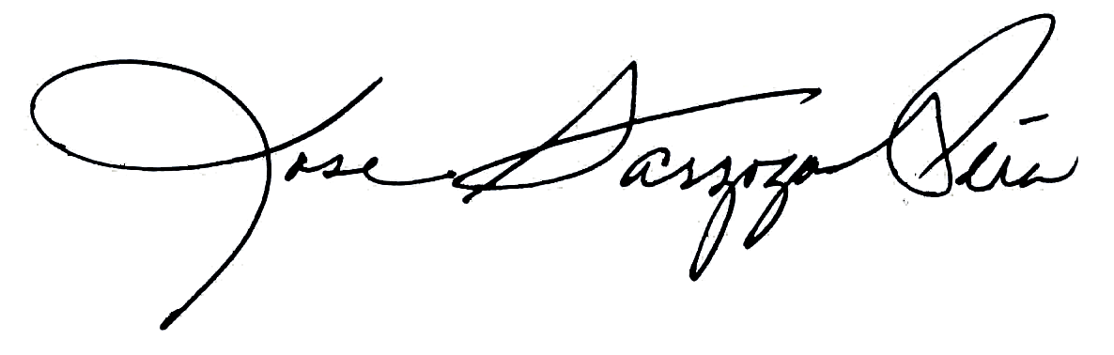
Rose Sarzoza-Pena
Manager, Board Services

